Katya Echazarreta
Fall 2017
Ankur Mehta
LEMUR

Project Proposal

Big Picture

Creation of personal robots is out of reach for the everyday non-technical individual due to the amounts of engineering related knowledge necessary. The goal of robot compiler is an interface to compose a robotic system without needing to understand the technical details, and without the need to devote time and money into the project. Currently, a python based interface is being worked on to be able to generate printable patterns, electronic specifications, and code. This is important because with this interface, the everyday user will be able to select automated designs based on their own specifications of function. As a result, robot construction will be simpler for a non-engineer than ever before. A current drawback is that there is currently a need for an interface that generates automatic traces for connecting pins based on an input of robot body pattern and location of pins to be connected. This interface needs to be created and eventually woven into the current robot compiler interface.

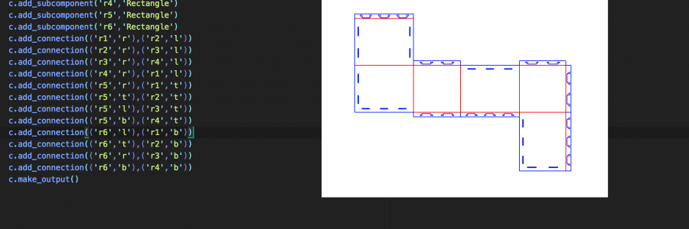
Figure 1: Body pattern of robot that will serve as input for automatic generation of PCB traces

Initial Personal Overview

The general personal goal is to create an interface that generates traces for pin connection taking into account the obstacles of the robot body pattern. This contributes to the big picture because it is vital for the final construction of the robot. This interface should be automatic and be able to generate the specific trace based on user desired functions of the robot. The most important part of getting my project started is doing an extensive literature review of the current standing of the Robot Compiler project so I know exactly from which point I must build off of. The next steps involve research on whether this desired interface for a trace generator is possible under current Open Source Electronic Design Automation (EDA) software such as KiCAD, or whether the interface must be created from scratch using python. Small, but very important goals in this process will include creating working prototypes in order to find the most desirable material for the traces. This analysis will include factors such as cost, reliability, availability of product and simplicity of use. We will know this sub problem has been solved when we are able to generate any trace pattern regardless of body design inputs and we can successfully use those traces on working prototype models. Beyond solving a sub problem of the Robot Compiler project, we are also successfully eliminating the need for costly PCB boards on our designs and effectively lowering the cost of the robot.

Background / related work / references
- What foundation and fundamentals need to be known in order to understand the your problem, approach, and solution?
- What work has been done before on this specific problem?
- What are related problems that have been addressed?
- What work has been done on those related problems?
- How does this past work contribute to your proposed solution?
Be sure to cite all potential sources, and summarize each one in terms of its content and relation to your project.

Background Research
-To be added as week 5,6 and 7 goal

Hierarchy

The final goal for this quarter is to have a working prototype robot made out of the RoCo generated body patterns and will have working trace patterns made out of the chosen conductive material.

In order to achieve this goal, we need to have PCB and Schematic designs for the trace patterns on the Robot and we need to know what conductive material we will be using as well as the material’s conductive properties.

In order to create the trace patterns for the Robot, we need to know whether we will be able to use the robot body design directly on our EDA or we will have to work around it. Also, in order to know the conductive material, we must perform tests and build simple circuits to calculate the conductive properties so we know whether these materials are good alternatives.

In order to know whether we can use the Robot body on our EDA directly, we must do extensive research and review on KiCAD and similar EDAs.

Based on this hierarchy it becomes apparent that there are two independent paths to this quarter’s project. One being the need for EDA research and another being the need for information on our conductive material.

Weekly Goals

Week 2:
1. Project Proposal rough draft and Lab key
Deliverable: Proposal Rough Draft.

Week 3:
1. Finish solidifying project proposal and meet with current RoCo team in order to receive the information necessary to begin building specific goal.
Deliverable: Project Proposal draft number two.

Week 4:
1. Begin extensive research on current RoCo project and start Python tutorials.
2. Meet with somebody in RoCo team to get the interface working on my computer.
Task: Meet with Weber to get RoCo interface working.
Deliverable: Have working RoCo interface.

-
Week 5:
- Begin experimenting with possible trace materials
- Build simple RoCo generated design with fishing line
Task: Do DMM test on the 2 materials in the lab
Deliverable: Pros/ cons list of each material and conductivity/ surface information sheet as well as the answers to the following questions and placed in Project Proposal Background:
-What have people done using the metalized plastic (people have done it with flex pcb)
-What happens to the metal when you fold it
-Will it crack, will it short?

Week 6/7:
1. Begin extensively researching KiCAD to try to determine whether it can be manipulated to generate traces based on RoCo generated robot body patterns.
- Research similar EDAs
Task: Use RoCo generated design input as a key point of whether we can use this or not
Deliverable: List of capabilities of various EDAs as well as disadvantages in order to be able to conclude whether it can be molded to our needs and the Background section of my proposal with the following questions/comments answered and elaborated upon:
-Have people characterized kiCAD to modify it to do own things
-Has anyone tried to build a pcb on a weird shape
-What can we learn from what people have done with flex pcb board
-What kinds of folded robots have people built (has anyone done one made out of conductive or foldable material)?
-Origami inspired robot involving circuits

Week 8:
1.Make a design in RoCo
Task: Be able to extract design from interface.
Deliverable: RoCo cube design for prototype

Week 9:
1. Create schematic design for final prototype on KiCAD
2. Create PCB layout traces for final prototype
Task: Attempt to place the traces on the robot body design.
Deliverable: Usable trace patterns

Week 10:
1. Create physical traces on current RoCo body patterns
Task: Use chosen material for trace patterns
Deliverable: Prototype robot with successful and working trace patterns

